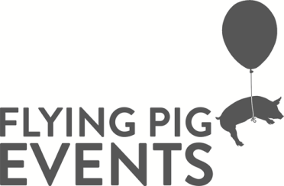

Whitehorse FReeZA Flying Pig Events Committee
Role Description

Coordinator: Youth Participation Officer
Classification: Volunteer

Tenure: 12 months (minimum with possibility of extension if decided upon by all parties)

Goal Statement: To support and provide young musicians, artists and creatives aged 12-25 opportunities to perform and participate in community by way of organizing music, cultural and arts based events in Whitehorse. To increase the profile of young musicians and artists and provide exposure for them in the local community and beyond.

Key Responsibilities:
- Implementation of activities and events relevant and attractive to young people
- Active promotion and marketing of FReeZA Flying Pig Events
- Participate in relevant training and skill development.
- Actively focus on providing opportunities to young musicians and artists advocating on their behalf and increasing their community profile online and in the wider community

FReeZA Flying Pig Position Specific Responsibilities:
- Attendance at all fortnightly FReeZA meetings is mandatory.
- Contribute to meetings including discussions, rotating meeting responsibilities, secretary, social media coordinator and treasurer roles.
- Respect other committee member’s opinions.
- Active involvement in the planning, organization and implementation of key FReeZA activities.
- Communicate with others in the committee and respond to emails, messenger chats and texts especially in between meeting times.
- Set goals and identify personal development areas.
- Understand and meet all requirement of the ‘Expectations of Commitment’ document.

Decision Making:
- The position will make decisions and implement actions based on FReeZA funding requirements with young people in the municipality, youth services staff and councils ‘Whitehorse Municipal Youth Plan’.

Key Relationships:
- The position will liaise with key stakeholders including; council youth services staff, youth organizations and young people in the municipality, community groups and any relevant parties necessary to carry out set goals and objectives.
- The position is required to maintain professional relationships with council members, youth services staff, youth service organizations and members of the general public.

Skills and Qualities Required:
- Enthusiasm
- Commitment
- Basic understanding of event management
- Willingness to learn
- Understanding and respect of confidentiality
- Sound communication skills

Training / Supervision provided:
- Training in the relevant areas including event management, promotions and marketing including mandatory compliance training upon commencement in the program.
- Regular and ongoing supervision by youth services staff at all times.

Please note:
- It is a requirement that all FReeZA volunteers over the age of 18 hold a valid Working With Children Check
- It is a requirement that all FReeZA volunteers over the age of 16 undergo a National Police Criminal History Check.
- It is a requirement that all FReeZA volunteers complete the necessary paperwork and training in stipulated timeframes.
- It is expected that if a committee member is experiencing difficulty in continuing with FReeZA that they approach the coordinator as soon as possible to discuss options.
- It is required that FReeZA volunteers have a laptop or device they can bring to fortnightly committee meetings.

