Position title: Maternal & Child Health Nurse
Classification: Universal Maternal & Child Health Nurse | Effective Date: November 2026
Reports to: Team Leader Maternal & Child Health | Tenure: Permanent/Temporary/Casual

About Us:
At Whitehorse City Council, community is at the heart of everything we do.
We aspire to be a healthy, vibrant, prosperous and sustainable community. We enable this through strong leadership and community partnerships.
We strive to stay ahead of evolving changes and needs of our community.
Our five key principles empower our employees to be innovative and provide an excellent customer experience. We are a resilient organisation where everyone belongs.
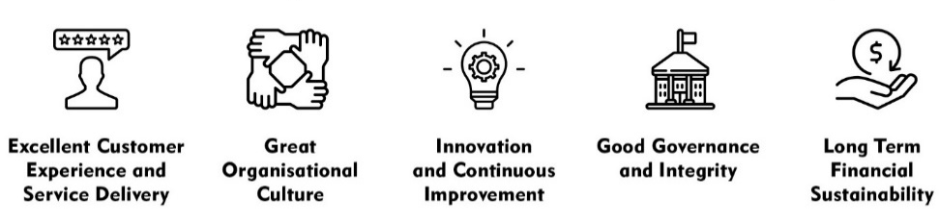

CREATe - Our Values and Behaviours:
Our shared values and behaviours are integral to how we go about our work, interact with each other and our community. Our employees ‘live’ these shared values. In living these values we also ensure that everyone has a voice and that everyone matters.
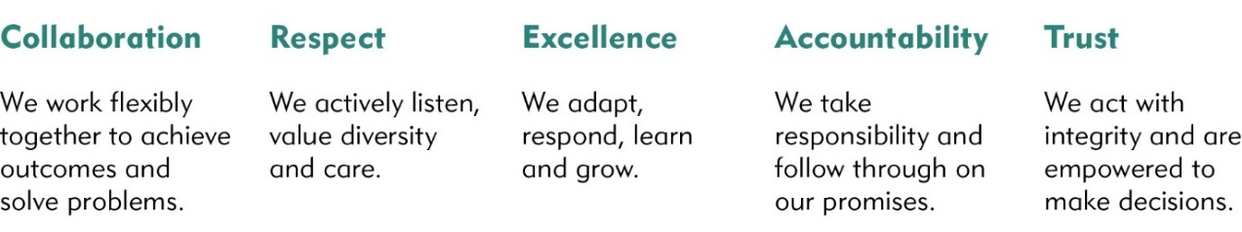
City of Whitehorse is a culturally and linguistically diverse community. We are proud of the diversity of our workforce and recognise the strength this provides in meeting the needs of our community. We are committed to upholding a safe, inclusive and respectful workplace that values the contribution of all.
Whitehorse City Council is committed to being a child safe organisation. We recognise our responsibilities to keep children and young people safe from harm and have established policies, procedures and training to achieve these commitments.

Goal Statement
The Universal Maternal & Child Health Service [UMCHS] is funded and operated by the Department of Health (DoH) and Whitehorse City Council (WCC). Delivery of the program is subject to parameters in the Memorandum of Understanding between DoH and the Municipal Association of Victoria, which represents local government, the MCH Program Standards and Guidelines (DHHS 2019) and continued funding from DoH.
The UMCHS provides a comprehensive and focused approach for the promotion, prevention and early intervention of the physical, emotional and social factors affecting young children 0-5 years and their families. The UMCHS supports child and family health, wellbeing and safety, focusing on infant and maternal health and father inclusive practice as key enablers to optimise child learning and development.
The Universal Maternal and Child Health Nurse provides a professional, comprehensive, evidence-based approach to assessing and supporting the physical, emotional or social factors affecting families and young children in the Whitehorse community.
This position primarily relates to the delivery of the Universal Maternal and Child Health Service (UMCHS). Nurses may be offered opportunities to participate in Enhanced Maternal and Child Health (EMCH) service delivery, based on operational need and professional development goals.

Key Responsibilities
Position Specific Responsibilities

Provide support in a non-judgmental, safe environment for families by conducting regular consulting sessions offering guidance and advice on a wide variety of child care, parenting and family related issues.

Assess, monitor and promote the health, growth, development and behaviour of young children 0 – 5 years including physical, social, emotional and intellectual status

Provide health education and support groups for first time mothers and other service users where there is an identified need

Respond to the needs of families with complex risk factors and target groups as defined in the Maternal and Child Health Program Resource Guide and the Key Ages and Stages Practice Guidelines

To deliver a professional, timely and responsive maternal and child health service to vulnerable families

Provide appropriate information, support and referral as necessary to ensure healthy outcomes for all children in the context of the program

Identify and escalate concerns regarding child wellbeing, family risk factors, or service access to the Maternal and Child Health Team Leader or Coordinator, in line with service protocols. Awareness of and responsiveness to the diverse needs of families, including those from culturally and linguistically diverse (CALD) backgrounds, Aboriginal and Torres Strait Islander families, LGBTQIA+ parents and carers, people with disabilities, and other vulnerable populations.

Conduct and maintain accurate records, record service deliveries in CDIS in accordance with the Maternal and Child Health Resource Guide and Program Standards (DHHS 2019)

Follow all procedures available to promote safety and security when visiting families in the home

Comply with the mandatory reporting of children at risk to the Department of Family, Fairness & Housing, in accordance with legal requirements

Comply with all legislative responsibilities under the Child Information Sharing Scheme (CISS), Family Violence Information Sharing Scheme (FVISS), and the Multi-Agency Risk Assessment and Management (MARAM) Framework when identifying, assessing, and responding to child wellbeing or family violence concerns.

Where applicable, support the delivery of the Enhanced Maternal and Child Health (EMCH) service in accordance with the Enhanced MCH Guidelines

Manage the Maternal and Child Health Centre as part of a team

Attend regular Maternal and Child Health team meetings and participate in the Maternal and Child Health service goals and objectives
- Participate in regular clinical supervision, reflective practice sessions, and peer support, as appropriate to the role and employment arrangement.

Corporate Responsibilities
- Adhere to all Corporate Policies, Procedures and the Organisational Goals and Values in the current Whitehorse City Council Collective Agreement.
- Understand and adhere to the Risk Management Policy (as it relates to the employees work area) and related procedures that are designed to minimise injury and/or loss to individuals, assets and equipment.
- Report any matters that may impact on the safety of Council employees or citizens, assets and equipment.

Accountability and Extent of Authority
Budget: Nil
Staff responsibility: Support and mentor MCH, midwifery and nursing students

Judgement and Decision Making
- Escalate clinical or operational concerns beyond scope to appropriate senior staff, including the Team Leader or Coordinator, to support timely decision-making and service continuity.
- Maintain a professional code of ethics in line with the Australian Midwifery & Nursing Federation and APHRA.
- Identify risks and vulnerabilities and report child abuse in accordance with council and state government policies and legislation

Specialist Knowledge and Skills
Licences and Experience:
- Current registration as a general nurse, midwife and maternal and child health nurse.
- Knowledge and understanding of current MCH Program Standards (DHHS 2019) and MCH Practice Guidelines (DHHS 2019)
- Knowledge and understanding of family partnerships, child development, mental health, family violence, and relevant frameworks including the Child Information Sharing Scheme (CISS), Family Violence Information Sharing Scheme (FVISS), and the MARAM Framework.
- Knowledge of relevant legislative requirements
- Evidence of 40 hrs CPD per year as per requirements for registration with APHRA
- Experience in providing Maternal and Child Health services
- Ability & willingness to contribute to the planning and development of the service
- Knowledge of relevant community resources
- Ability to participate in nursing/other research as agreed by the MCH team
- Familiarity with relevant clinical documentation systems, Microsoft Office Suite, cloud-based platforms, and telehealth tools as adopted by Council
- Demonstrated experience in comprehensive assessment and effective referral to appropriate services
- Proficiency in preparing clear, concise, and professional reports
- Ability to communicate in community languages such as Mandarin or Cantonese (highly regarded)
- Proven commitment to continuous quality improvement and evidence-informed practice

Qualifications and Experience
Qualifications/ Certificates:
- List essential qualifications (including any qualifications including certificates).

Interpersonal Skills
- Excellent interpersonal and communication skills to facilitate clear communication with a diverse range of families, other professionals and team members
- Capacity to engage vulnerable families and address risk and disadvantage in collaboration with other professionals/organisations
- Demonstrated highly developed time management and organisational skills
- Comprehensive written skills to ensure accurate recording of service delivered
- Ability handle and resolve crisis situations
- Capacity to self-reflect and communicate workplace support and development needs
- Awareness of and attention to professional self-care
- Ability to work autonomously and in a team environment.

Key Relationships:
- Maintain collaborative communication with senior MCH leadership to ensure timely escalation of clinical concerns and appropriate delegation of duties.
- Work in partnership with Health and Family Services staff to support integrated service delivery
- Engage with relevant Council departments to ensure alignment with organisational objectives
- Liaise with State, Local, and Federal Government agencies as required
- Build and maintain constructive relationships with external service providers to support client outcomes
- Foster professional connections with universities, training institutions, community groups, and other key

Management Skills
- Ability to support and mentor students from appropriate disciplines
- Ability to maintain data and statistics accurately
- The position requires skills in managing time, setting priorities, flexibility, planning and organising one’s own work and in appropriate circumstances that of other employees so as to achieve specific and set objectives in the most efficient way possible and within the resources available

Application Requirements
- Satisfactory National (and International as applicable) Criminal History Check.
- Working with Children Check.
- A valid Victorian driver’s licence.
- Shortlisted candidates may be required to attend a pre-employment medical assessment and/or psychometric testing.
- Successful applicants must be prepared to be located at any site within the City of Whitehorse.
- This position has been identified as an “at risk” role which may have a potential occupational exposure to a vaccine preventable, communicable disease. It is a requirement that the incumbent receives immunisation in accordance with the Council’s Staff Immunisation Program

Key Selection Criteria
1. Current registration as both and AHPRA registered nurse and registered midwife as a well as postgraduate qualifications in Child & Family Health.
2. Excellent interpersonal and communication skills to ensure clear communication with a diverse range of families, other professionals and team members
3. Experience as a Maternal and Child Health Nurse and the ability to identify, respond to and refer families with complex risk factors
4. Demonstrated highly developed organisational skills and the ability to maintain accurate and timely records in accordance with the Maternal and Child Health Resource Guide and applicable legislative requirements
5. Ability to provide health promotion education and support to families, utilising a family-led model of care

Physical Requirements

Physical Functional Demand | Physical Tasks for the Role | Frequency/Duration of performance of task per day | Comments
Kneeling/Squatting  Tasks involve flexion/bending at the knees, ankle, and waist in order to work at low levels. | Helping with floor-based developmental assessments or engaging children in play during visits | Intermittent throughout the shift
Hand/Arm Movement  Tasks involve use of hand/arms | Computer use and completing physical assessments, measuring infants, writing notes | Repeated frequently across all appointments
Bending/Twisting  Tasks involve forward or backward bending or twisting at the waist. | Manipulating children on scales, retrieving supplies from low storage | Intermittent throughout the shift
Standing  Tasks involve standing in an upright position | Conducting consultations, physical assessments, or group sessions | Intermittent throughout shift
Reaching  Tasks involve reaching above head, and above and equal to shoulder height | Accessing high cupboards or storage shelves | Intermittent throughout shift
Walking  Tasks involve walking on slopes and walking whilst pushing/pulling objects | Between rooms, within centres, and while pushing equipment during home visits | Intermittent throughout shift
Lifting/Carrying  Tasks involve raising, lowering and moving objects from one level position to another | Carrying home visit bag and portable scales; collecting clinical resources for centres; lifting calibration weights (e.g. 5kg) for scales | Intermittent throughout shift | Encourage use of wheeled trolley where possible
Physical Functional Demand | Specific Physical Job Tasks | Frequency/Duration of performance of task per day | Comments
Pushing/Pulling  Tasks involve pushing/pulling away, from and towards the body | Using trolley for transporting resources or equipment between rooms/sites; adjusting furniture for group setup | Intermittent throughout shift
Keyboard Duties  Tasks involve sitting at workstation and using computer | Inputting clinical notes, writing reports, responding to emails, online training, using laptop at home visit | Required throughout shift
Satisfactory Vision  Standard of vision required equal to that required for driver’s licence | Reading charts, digital screens, forms, and client documentation | Required throughout shift

