Pre- commencement Report

For Asset Protection Permit Application
DATE: insert date here
Property Address: Insert address here
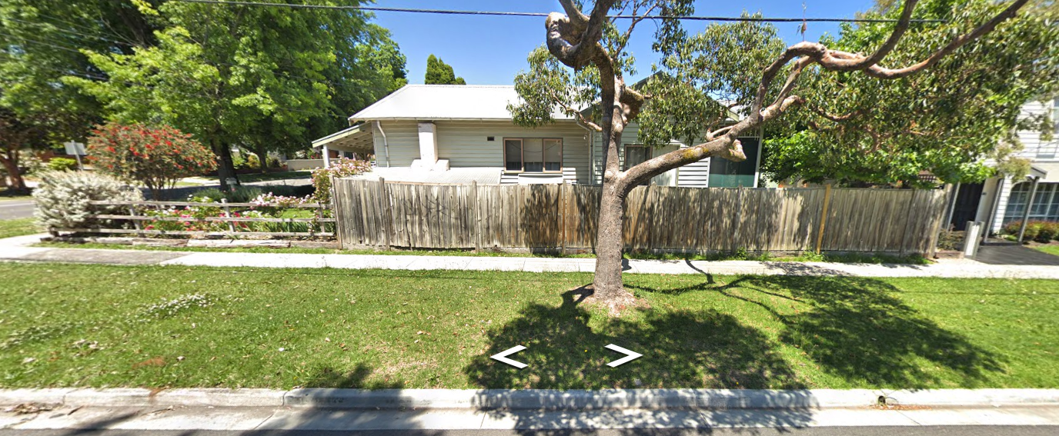
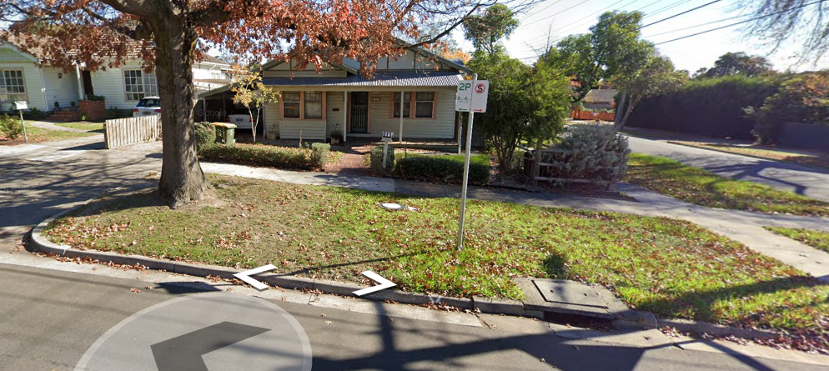

Council Assets
- Footpath
Observed condition
photos
- Kerb
Observed condition
Photos
- Nature Strip
Observed condition
Photos
- Vehicle Crossing
Observed condition
Photos
- Street Trees
Observed condition
Photos
- Road
Observed condition
Photos
- Other Assets
Observed condition
Photos

